ANALYSE OF REDDIT 2017-01-03

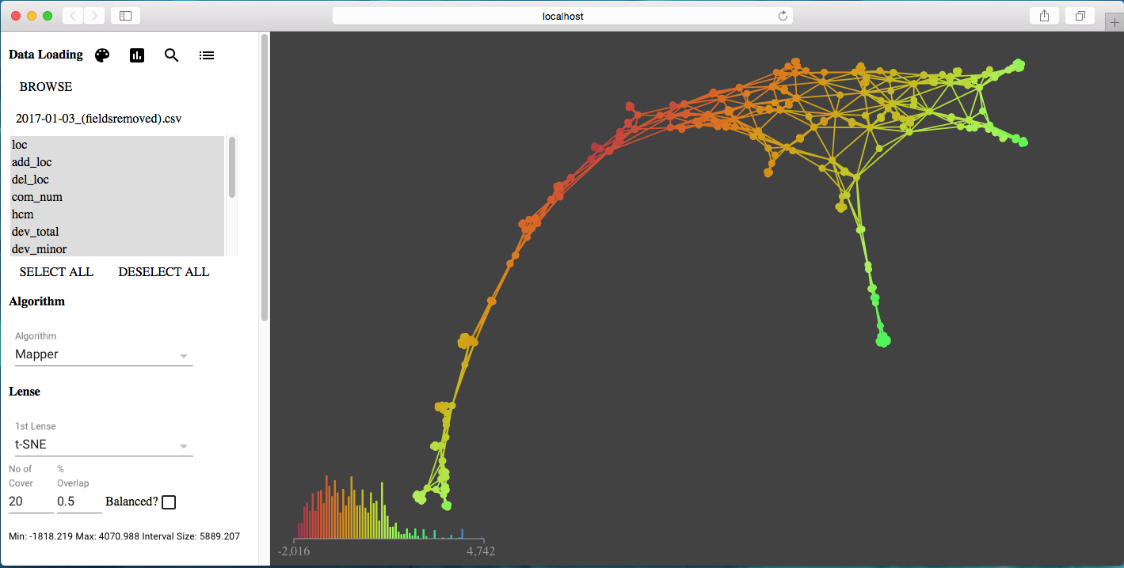

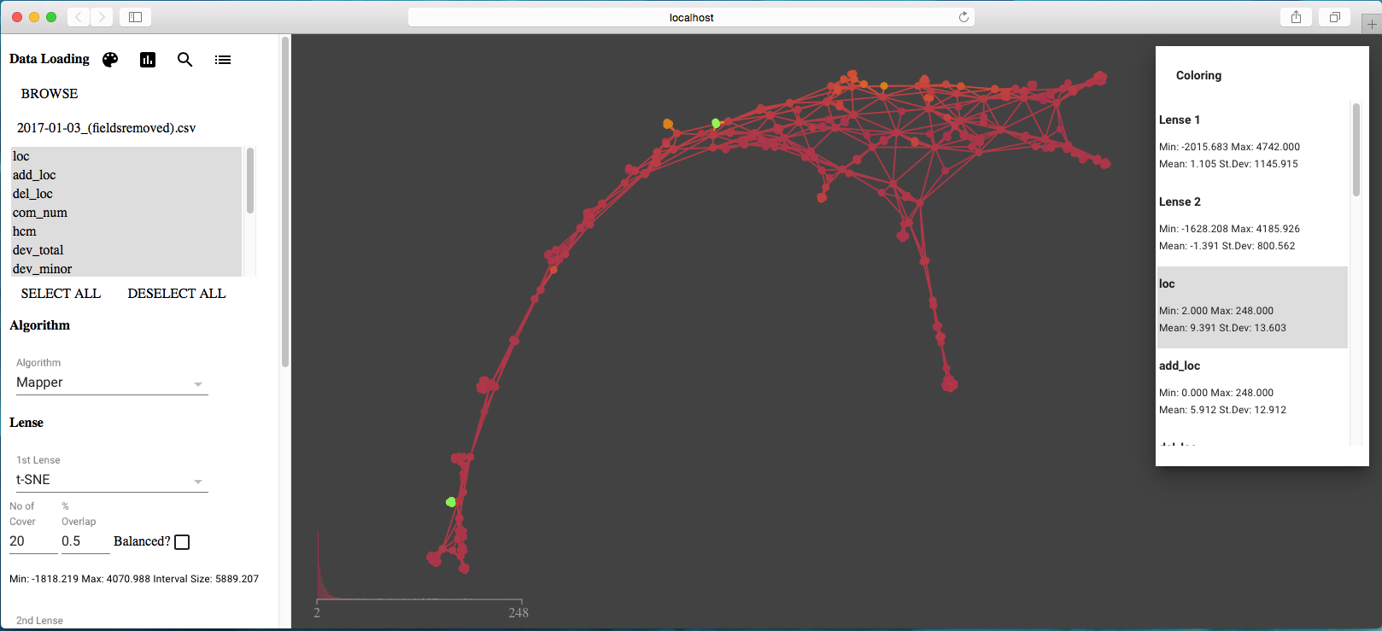

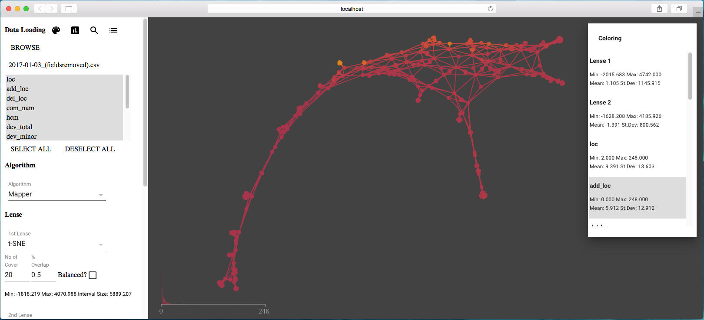

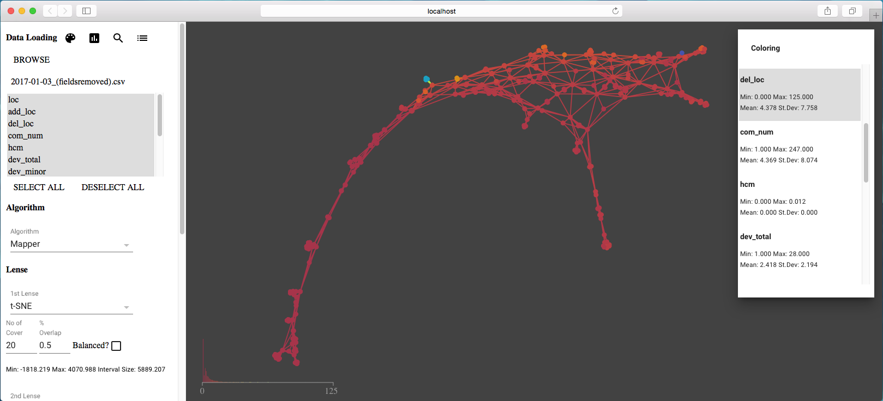

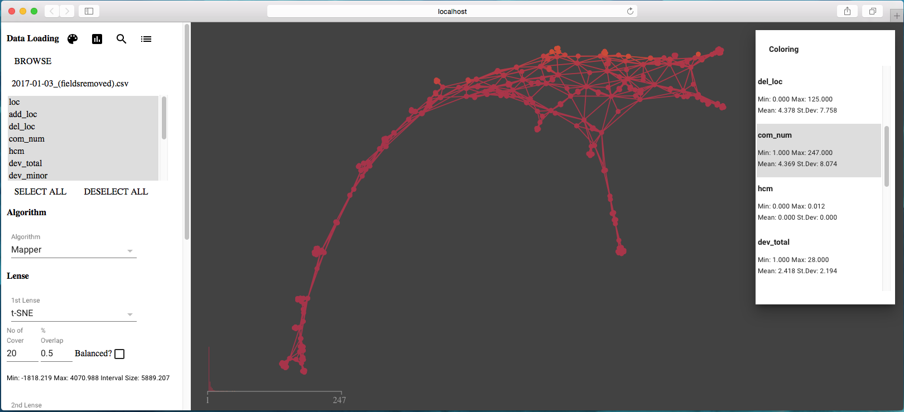

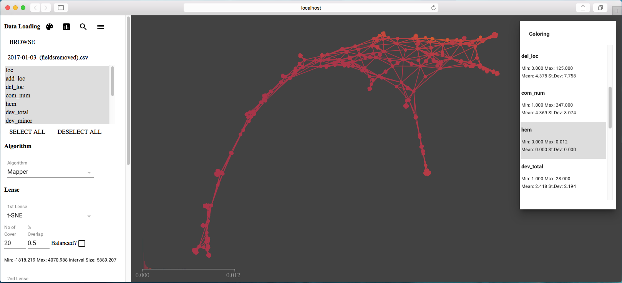

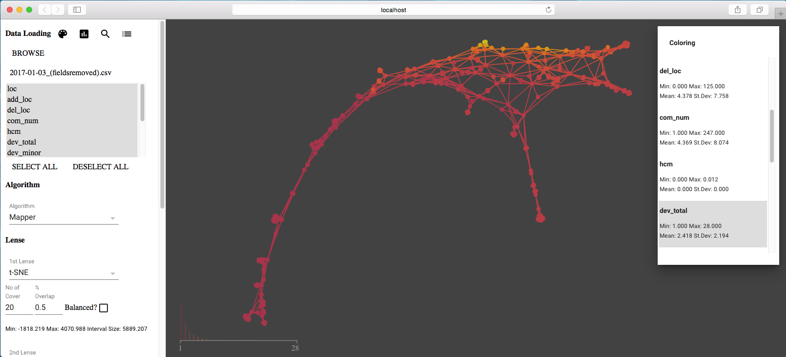

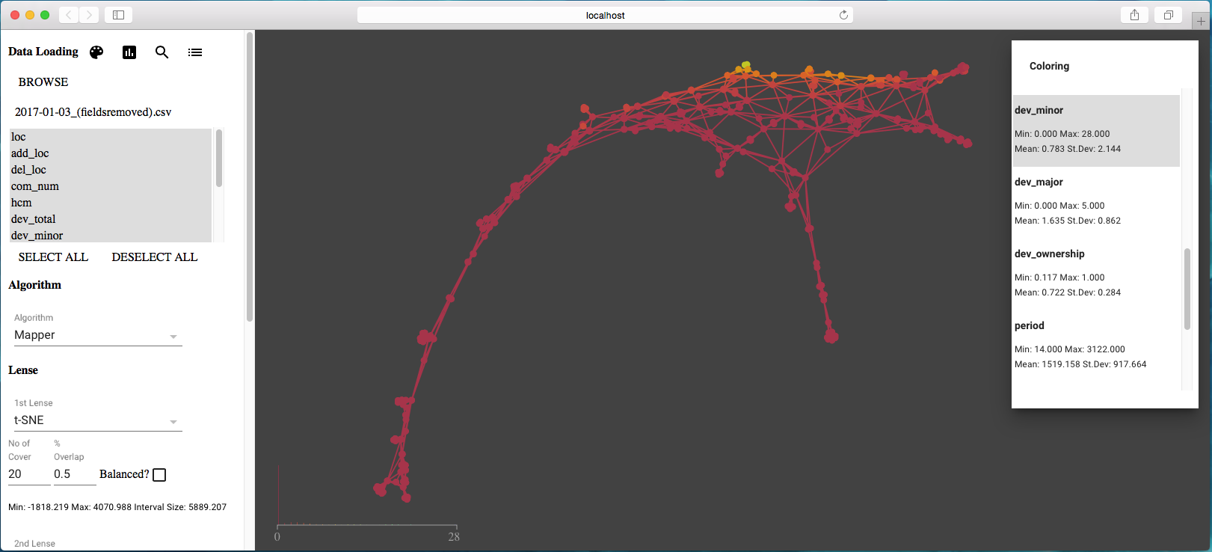

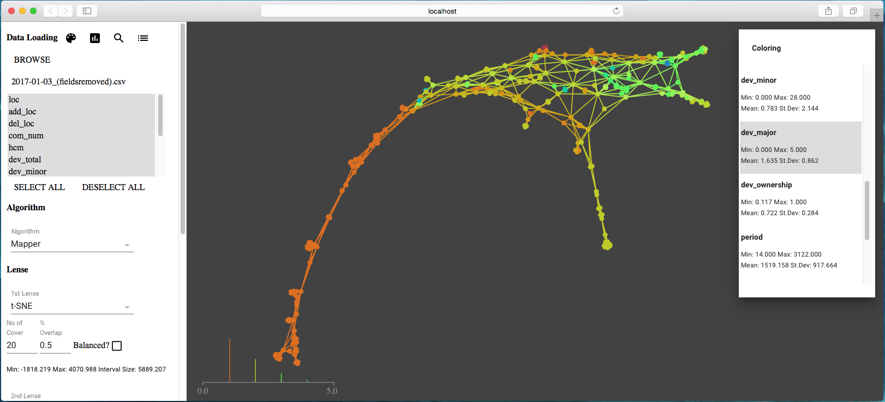

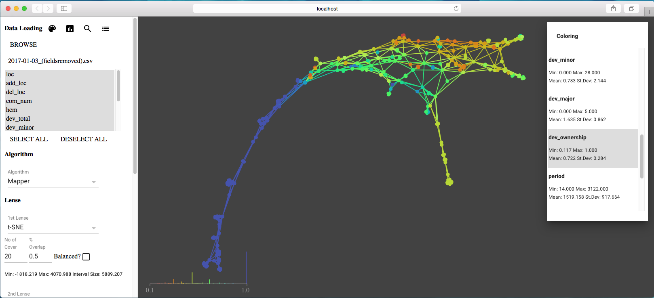

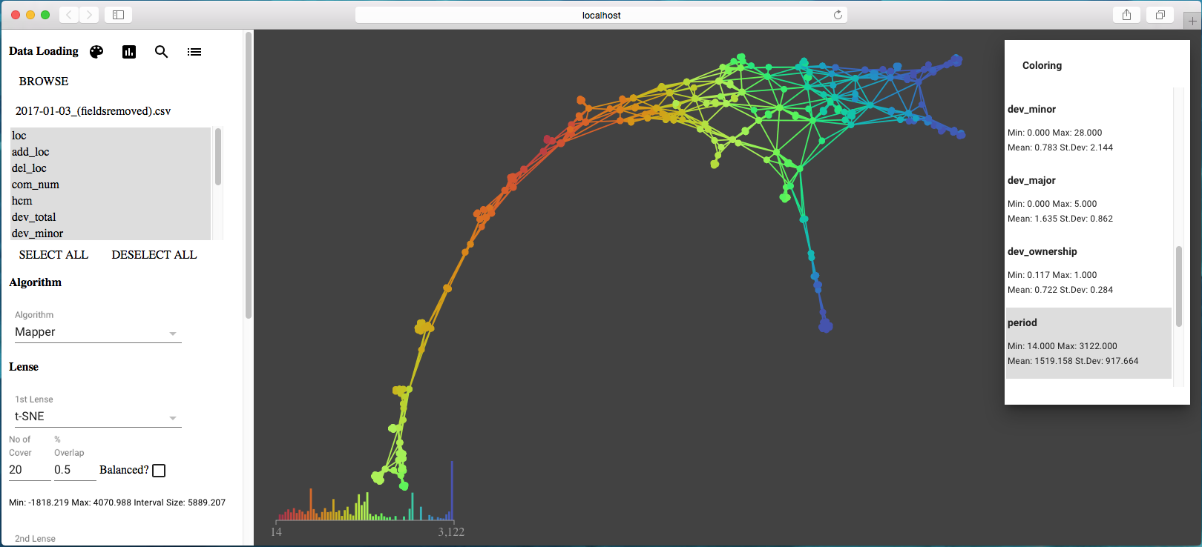

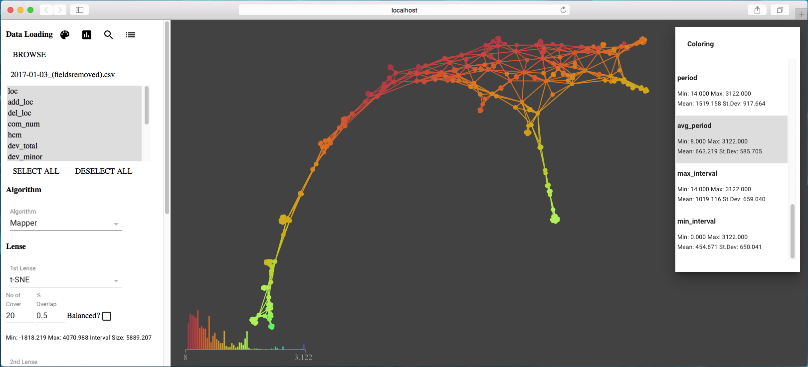

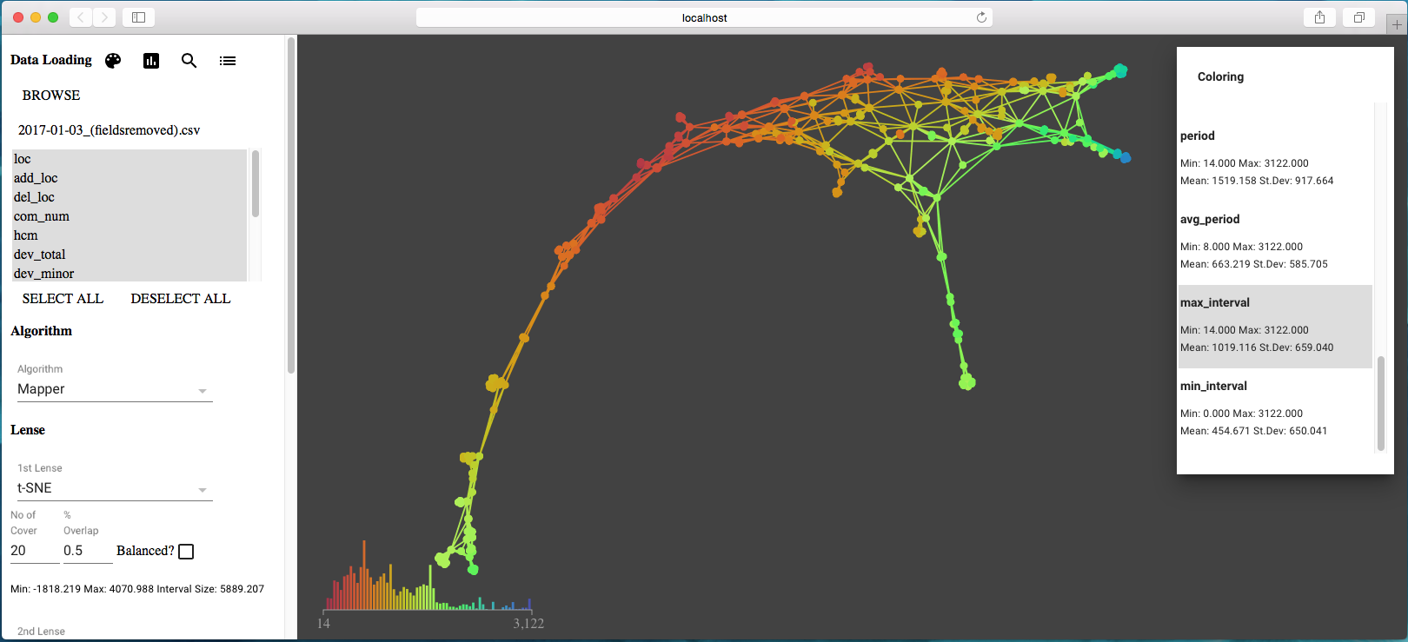

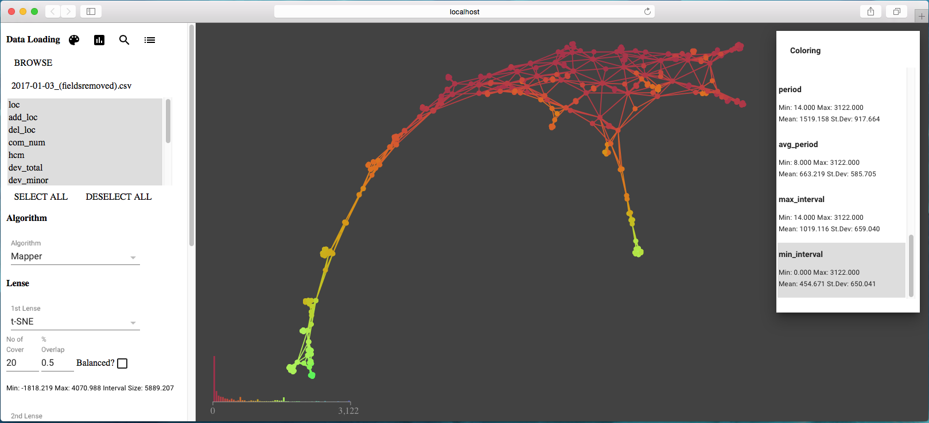

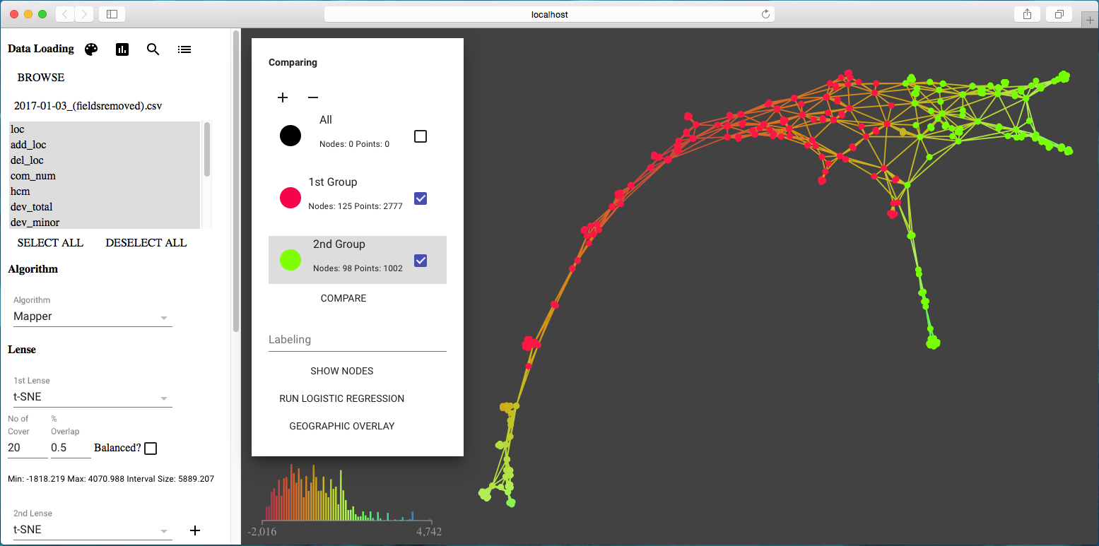

#### Analysis Result

|  |  |  |  |  |  |  |  |  |
| --- | --- | --- | --- | --- | --- | --- | --- | --- |
| **Variables** | **Group 1 min** | **Group 2 min** | **Group 1 mean** | **Group 2 mean** | **Group 1 median** | **Group 2 median** | **Group 1 max** | **Group 2 max** |
| loc | 2.0 | 2.0 | 9.057 | 12.768 | 6.0 | 6.0 | 131.0 | 248.0 |
| add_loc | 0.0 | 0.0 | 5.263 | 11.83 | 2.0 | 6.0 | 75.0 | 248.0 |
| del_loc | 0.0 | 0.0 | 4.248 | 7.818 | 2.0 | 5.0 | 106.0 | 125.0 |
| com_num | 1.0 | 2.0 | 3.374 | 9.537 | 2.0 | 6.0 | 74.0 | 247.0 |
| hcm | 0.0 | 0.0 | 0.0 | 0.001 | 0.0 | 0.001 | 0.002 | 0.012 |
| dev_total | 1.0 | 1.0 | 2.047 | 4.584 | 2.0 | 4.0 | 16.0 | 28.0 |
| dev_minor | 0.0 | 0.0 | 0.44 | 2.416 | 0.0 | 1.0 | 15.0 | 28.0 |
| dev_major | 0.0 | 0.0 | 1.607 | 2.168 | 1.0 | 2.0 | 5.0 | 5.0 |
| dev_ownership | 0.167 | 0.117 | 0.753 | 0.438 | 0.909 | 0.4 | 1.0 | 1.0 |
| period | 14.0 | 1689.0 | 986.536 | 2742.227 | 951.0 | 2851.0 | 2424.0 | 3122.0 |
| avg_period | 8.0 | 12.0 | 422.215 | 518.379 | 354.0 | 446.0 | 1088.0 | 1561.0 |
| max_interval | 14.0 | 166.0 | 680.547 | 1307.177 | 616.0 | 1231.0 | 1904.0 | 2898.0 |
| min_interval | 0.0 | 0.0 | 255.957 | 108.703 | 114.0 | 10.0 | 1088.0 | 1546.0 |